Day-4
Connecting and testing peripheral devices

1.Connect a USB webcam to your computer, install any required drivers, and verify that the webcam works by opening the default camera app and capturing a photo.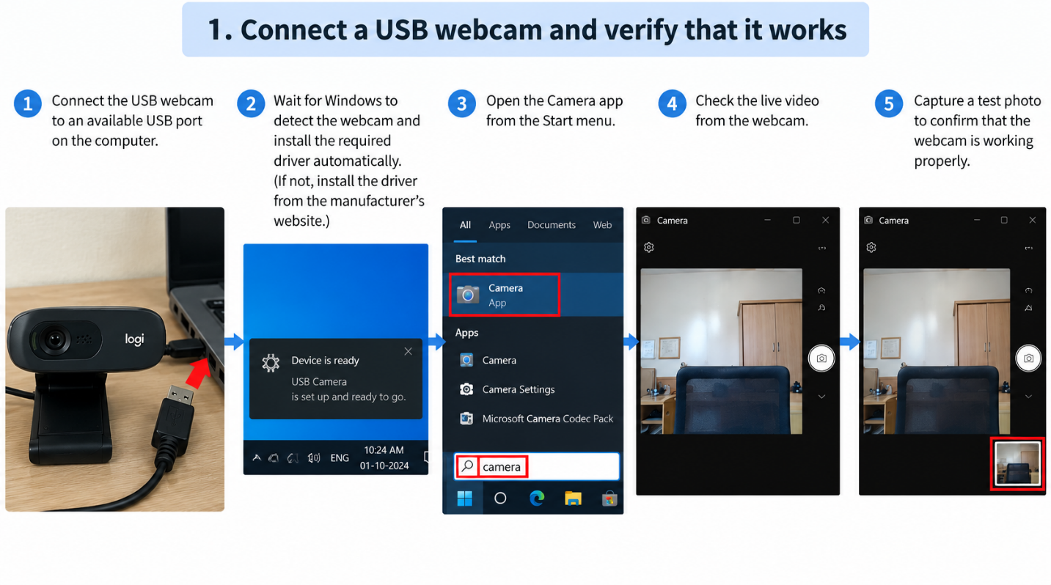
1. Connect a USB Webcam and Verify It Works
Steps:
- Connect the webcam
Plug the webcam's USB cable into an available USB port on the computer.
- Wait for Windows to detect it
Windows should automatically detect the webcam and install the required driver. A notification may appear saying that the device is ready.
- Install the driver if required
If Windows cannot detect the webcam automatically, install the appropriate driver provided by the webcam manufacturer.
- Open the Camera app
Click the Start button and search for Camera. Open the Camera app.
- Check the live video
If the webcam is working correctly, you will see the live video from the webcam in the Camera app.
- Capture a test photo
Click the camera/shutter button in the Camera app to take a photo. Check the preview/thumbnail to confirm that the photo was captured.
Result:
The USB webcam is successfully connected, detected, and verified by capturing a test photo.

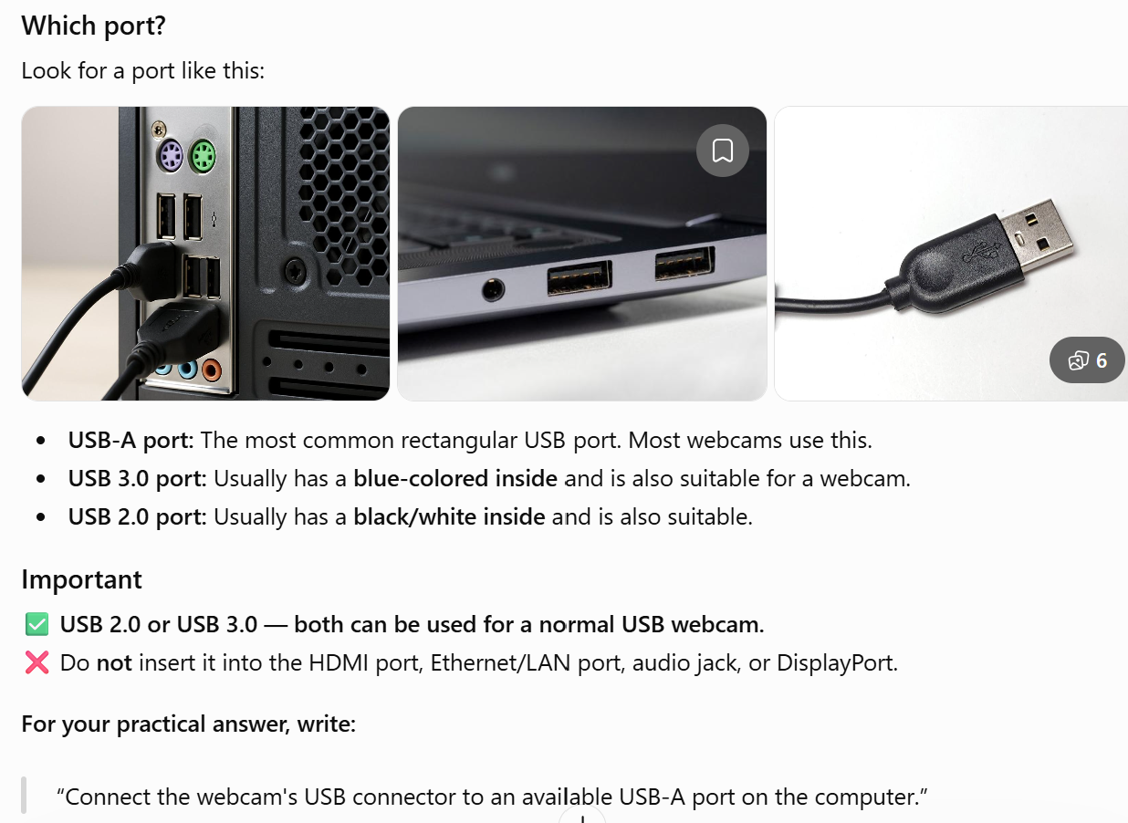

2.Set up a local printer (USB or network), install the correct driver, and print a test page to confirm successful installation.
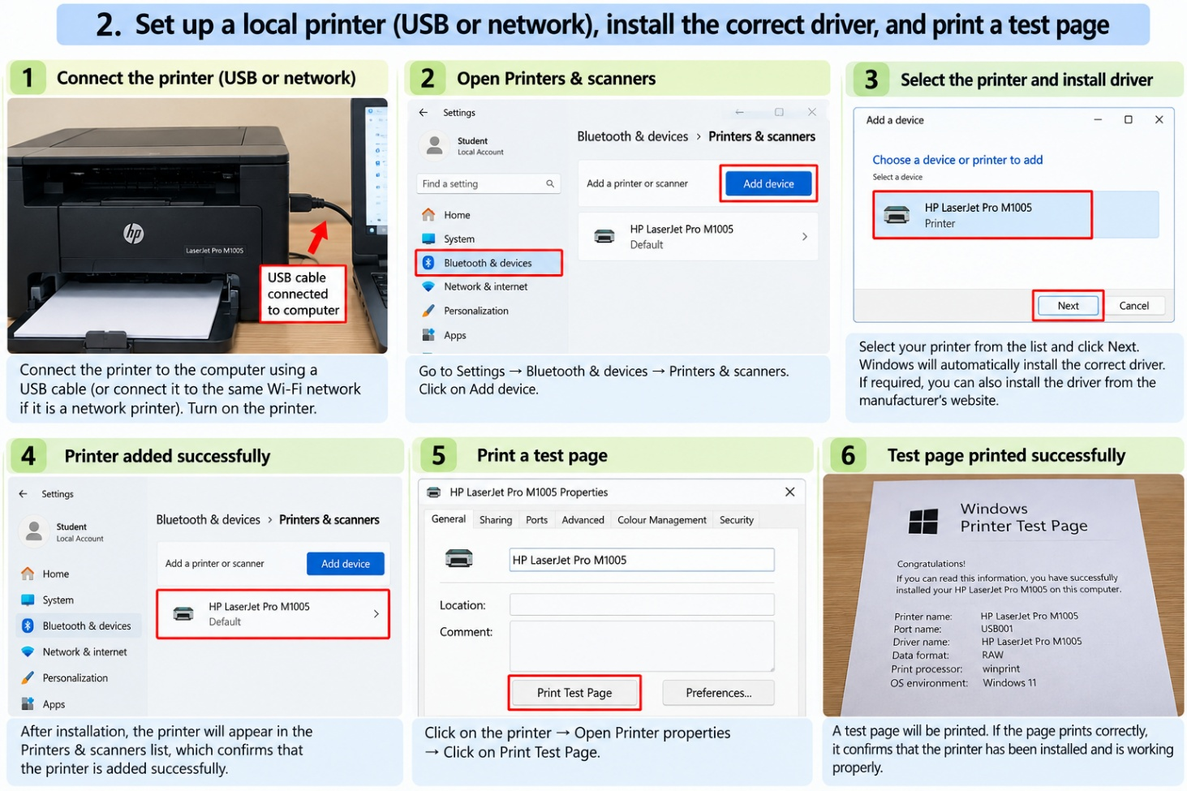

3.Simulate a connectivity issue by unplugging the printer's USB cable, then use Windows Device Manager to identify and resolve the 'printer not detected' problem.
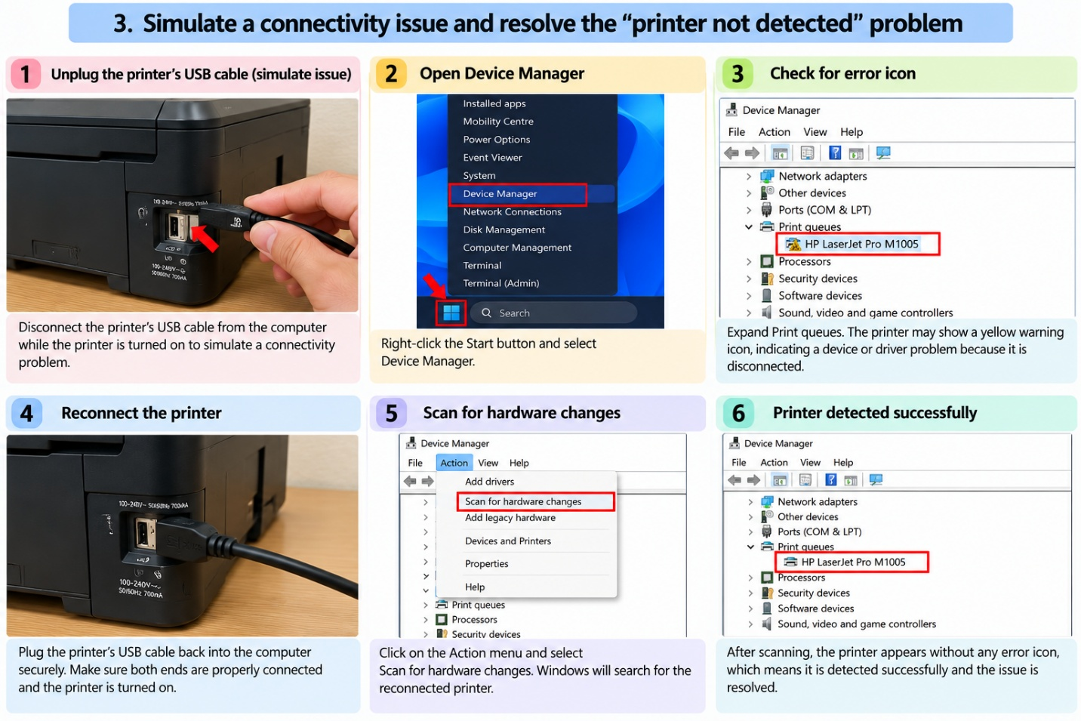

4.A user reports that their webcam video is not displaying in Zoom, but it works in the default camera app. Troubleshoot and resolve the issue so the webcam works in both applications.
